BO RUN

Paramétrage planification Etat BO RUN

- Implémentation la plannification :
Pour assurer l’envoie automatique de certains Etats BO , il faut les ajouter sous la table etat_borun_9alf avec la requête suivante :

SELECT * from etat_borun_9alf for update
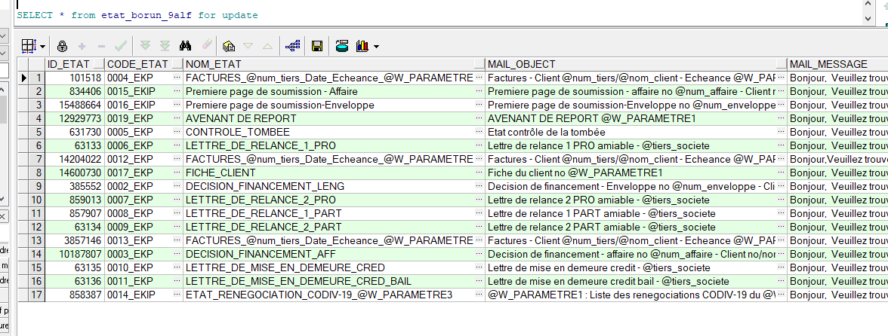
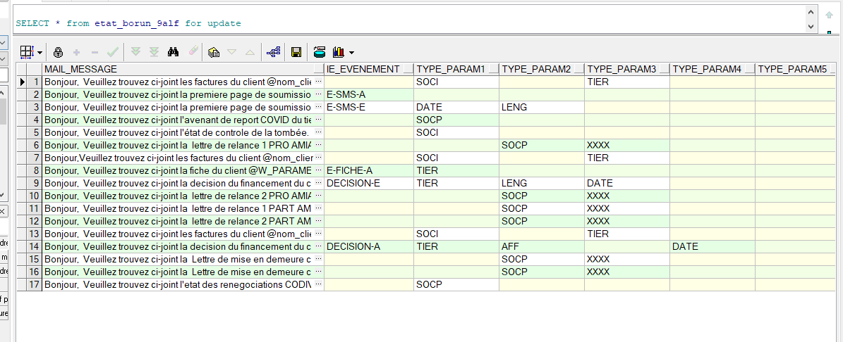
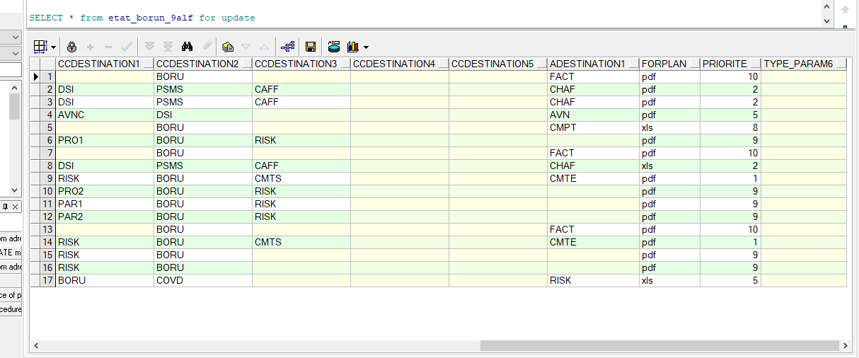

- Champs à remplir pour que la procédure du lancement puisse déclencher l’envoie des états :

Colonne | Description
- ID_ETAT : | - Contient l’ID de l’etat qui se trouve sur BO (propriétés)
- CODE_ETAT : | - Le code etat est une codification interne pour l’identifier afin de l’envoyer comme paramètre pour la procédure spécifique  (Expl : DB_LANCE_ETAT_BO_9ALF)
- NOM_ETAT : | - Contient le nom de l’etat qui peut également contenir des paramètres appelés par @ (Expl : @tiers_societe)
- MAIL_OBJECT : | - Contient l object du mail qui ramène l’etat BO qui peut également contenir des paramètres appelés par @ (Expl : @num_client)
- MAIL_MESSAGE : | - Contient le corps d’email qui ramene l’etat BO qui peut également contenir des paramètres appelés par @ (Expl : @nom_client)
- IE_EVENEMENT : | - Nom de l’évènement
- TYPE_PARAM1 : | - Les paramètres à appelés (6 max)
- CCDESTINATION1 : | - Le groupe des destinataires en copie qui recevront l’email de l’etat BO (5 groupes max, Expl : DSI, RISK)
- ADESTINATION1 : | - Le groupe des destinataires principaux qui recevront l’email de l’etat BO (5 groupes max, Expl : FACT)
- FORPLAN : | - Le type de l’etat à envoyer dans l’email (Expl : xls,pdf)
- PRIORITE : | - De 1 à 10 pour prioriser l’envoie en simultané si y en a des états planifiés en même temps

- Script à créer :
Script de la procédure DB_LANCE_ETAT_BO_9ALF qui prend l’ID objet, code objet, code etat et les paramètres pour envoyer l’etat convenable selon la planification :
---------------------------------------------------------------------------------------------------------------------------
CREATE OR REPLACE PROCEDURE DB_LANCE_ETAT_BO_9ALF(
P_ID_OBJET IN NUMBER ,
P_CODE_OBJET IN VARCHAR2,
P_CODE_ETAT IN VARCHAR2,
P_PARAMETRE1 IN VARCHAR2 DEFAULT NULL,
P_PARAMETRE2 IN VARCHAR2 DEFAULT NULL,
P_PARAMETRE3 IN VARCHAR2 DEFAULT NULL,
P_PARAMETRE4 IN VARCHAR2 DEFAULT NULL,
P_PARAMETRE5 IN VARCHAR2 DEFAULT NULL,
P_PARAMETRE6 IN VARCHAR2 DEFAULT NULL)IS
/*@BP***************************************************************************
* NOM : DB_LANCE_ETAT_BO_9ALF
-------------------------------------------------------------------------------
* DATE CREATION : 12/01/2018
* AUTEUR : HAMDI DAOUD
* MODIFICATION :
-------------------------------------------------------------------------------
* DESCRIPTION : PROJET BORUN
-------------------------------------------------------------------------------
* HISTORIQUE :
***************************************************************************@EG*/
W_BO_SERVER VARCHAR2(20) := 'SRV-BO4-TN';
W_AQ_ETAT_BORUN_TYPE AQ_ETAT_BORUN_TYPE;
W_ID_ETAT ETAT_BORUN_9ALF.ID_ETAT%TYPE;
W_NOM_ETAT ETAT_BORUN_9ALF.NOM_ETAT%TYPE;
W_ADRESSE_MAIL VARCHAR2(4000);
w_utilisateur VARCHAR2(20);
w_user_system VARCHAR2(100);
w_id_affaire NUMBER(10);
w_id_engaglign NUMBER(10);
W_DBNAME VARCHAR2(100);
w_ie_engaglign VARCHAR2(20);
w_ie_affaire VARCHAR2(20);
w_tiers_client VARCHAR2(10);
w_tiers_societe VARCHAR2(10);
w_nom_client VARCHAR2(200);
W_SI_SOURCE VARCHAR2(50):='EKIP';
W_MAIL_OBJECT VARCHAR2(4000);
W_MAIL_MESSAGE VARCHAR2(4000);
W_TYPE_PARAM1 VARCHAR2(4);
W_TYPE_PARAM2 VARCHAR2(4);
W_TYPE_PARAM3 VARCHAR2(4);
W_TYPE_PARAM4 VARCHAR2(4);
W_TYPE_PARAM5 VARCHAR2(4);
W_TYPE_PARAM6 VARCHAR2(4);
W_PARAMETRE1 VARCHAR2(400);
W_PARAMETRE2 VARCHAR2(400);
W_PARAMETRE3 VARCHAR2(400);
W_PARAMETRE4 VARCHAR2(400);
W_PARAMETRE5 VARCHAR2(400);
W_PARAMETRE6 VARCHAR2(400);
w_charge_affaire VARCHAR2(400);
W_CCDESTINATION VARCHAR2(4000);
W_CCDESTINATION1 VARCHAR2(4);
W_CCDESTINATION2 VARCHAR2(4);
W_CCDESTINATION3 VARCHAR2(4);
W_CCDESTINATION4 VARCHAR2(4);
W_CCDESTINATION5 VARCHAR2(4);
W_ADESTINATION1 VARCHAR2(4);
W_FORPLAN VARCHAR2(10);
W_COMITE VARCHAR2(12);
W_PRIORITE NUMBER(10);
w_util_op VARCHAR2(10);

CURSOR C_mail(P_tiers_societe IN VARCHAR2,
P_CCDESTINATION1 IN VARCHAR2,
P_CCDESTINATION2 IN VARCHAR2,
P_CCDESTINATION3 IN VARCHAR2,
P_CCDESTINATION4 IN VARCHAR2,
P_CCDESTINATION5 IN VARCHAR2) IS
SELECT DISTINCT LOWER(ADRESSE_MAIL) ADRESSE_MAIL
FROM adresse_mail_destination_9alf a
WHERE a.tiers_societe = P_tiers_societe
AND (a.type_poste = P_CCDESTINATION1
OR a.type_poste = P_CCDESTINATION2
OR a.type_poste = P_CCDESTINATION3
OR a.type_poste = P_CCDESTINATION4
OR a.type_poste = P_CCDESTINATION5);

CURSOR C_mail_A(P_tiers_societe IN VARCHAR2,
P_ADESTINATION1 IN VARCHAR2) IS
SELECT DISTINCT LOWER(ADRESSE_MAIL) ADRESSE_MAIL
FROM adresse_mail_destination_9alf a
WHERE a.tiers_societe = P_tiers_societe
AND a.type_poste = P_ADESTINATION1;
BEGIN

---VERIFICATION ETAT---

BEGIN
SELECT ID_ETAT,NOM_ETAT,MAIL_OBJECT,MAIL_MESSAGE,
TYPE_PARAM1,
TYPE_PARAM2,
TYPE_PARAM3,
TYPE_PARAM4,
TYPE_PARAM5,
TYPE_PARAM6,
CCDESTINATION1,
CCDESTINATION2,
CCDESTINATION3,
CCDESTINATION4,
CCDESTINATION5,
ADESTINATION1,
FORPLAN,
PRIORITE
INTO W_ID_ETAT,W_NOM_ETAT,W_MAIL_OBJECT,W_MAIL_MESSAGE,
W_TYPE_PARAM1,
W_TYPE_PARAM2,
W_TYPE_PARAM3,
W_TYPE_PARAM4,
W_TYPE_PARAM5,
W_TYPE_PARAM6,
W_CCDESTINATION1,
W_CCDESTINATION2,
W_CCDESTINATION3,
W_CCDESTINATION4,
W_CCDESTINATION5,
W_ADESTINATION1,
W_FORPLAN,
W_PRIORITE
FROM ETAT_BORUN_9ALF
WHERE CODE_ETAT = P_CODE_ETAT;
EXCEPTION
WHEN NO_DATA_FOUND THEN
DB_UTADM_ERREUR_OTHERS('SEL ETAT_BORUN_9ALF');
END;
---
---RECHERCHE DATABASE NAME---
---
BEGIN
SELECT GLOBAL_NAME
INTO W_DBNAME
FROM GLOBAL_NAME;
EXCEPTION
WHEN OTHERS THEN
DB_UTADM_ERREUR_OTHERS('SEL GLOBAL_NAME');
END;
---
---RECHERCHE ADRESSE MAIL---
---
IF W_ADESTINATION1 IS NULL THEN
BEGIN
SELECT u.utilisateur,
sys_context( 'USERENV', 'OS_USER' )
INTO w_utilisateur,
w_user_system
FROM UTILIS U
WHERE U.USR_CONNECT= USER;
EXCEPTION
WHEN OTHERS THEN
DB_UTADM_ERREUR_OTHERS('SEL UTILIS');

END;
ELSE
BEGIN
SELECT sys_context( 'USERENV', 'OS_USER' )
INTO w_user_system
FROM DUAL;
EXCEPTION
WHEN OTHERS THEN
DB_UTADM_ERREUR_OTHERS('SEL DUAL');
END;
END IF;
IF P_CODE_OBJET = 'AFF' THEN
---
--- Recherche du client
---
BEGIN
SELECT tiers_client,
eefa_tiers_lib(tiers_client),
ie_affaire,
tiers_societe,
id_affaire
INTO w_tiers_client,
w_nom_client,
w_ie_affaire,
w_tiers_societe,
w_id_affaire
FROM AFFAIRE
WHERE id_affaire = P_ID_OBJET;
EXCEPTION
WHEN OTHERS THEN
DB_UTADM_ERREUR_OTHERS('SEL AFFAIRE');
END;
ELSIF P_CODE_OBJET = 'TIER' THEN
---
--- Recherche du client
---
BEGIN
SELECT t.tiers,
eefa_tiers_lib(t.tiers),
g2.tiers_societe
INTO w_tiers_client,
w_nom_client,
w_tiers_societe
FROM TIERS T,
GROUPE_SGT G1,
GROUPE_SGT_9ALF G2
WHERE t.Id_tiers = P_ID_OBJET
AND t.id_groupe_sgt = g1.id_groupe_sgt
AND g1.ie_groupe_sgt = g2.ie_groupe_sgt;
EXCEPTION
WHEN OTHERS THEN
DB_UTADM_ERREUR_OTHERS('SEL TIERS');
END;
ELSIF P_CODE_OBJET = 'LENG' THEN
BEGIN
SELECT t.tiers,
eefa_tiers_lib(t.tiers),
l.ie_engaglign,
l.tiers_societe,
l.id_engaglign
INTO w_tiers_client,
w_nom_client,
w_ie_engaglign,
w_tiers_societe,
w_id_engaglign

FROM ENGAGLIGN L, TIERS T
WHERE l.id_engaglign = P_ID_OBJET
AND l.id_tiers_objet = t.id_tiers;
EXCEPTION
WHEN NO_DATA_FOUND THEN
SELECT t.tiers_principal,
eefa_tiers_lib(t.tiers_principal),
a.ie_engaglign,
a.tiers_societe
INTO w_tiers_client,
w_nom_client,
w_ie_engaglign,
w_tiers_societe
FROM ENGAGLIGN A,REGRTIERS T
WHERE A.ID_TIERS_OBJET = T.ID_REGRTIERS
AND A.id_engaglign = P_ID_OBJET;
WHEN OTHERS THEN
DB_UTADM_ERREUR_OTHERS('SEL TIERS');
END;
END IF;

IF W_TYPE_PARAM1 = 'SOCP' THEN
w_tiers_societe := P_PARAMETRE1;
ELSIF W_TYPE_PARAM2 = 'SOCP' THEN
w_tiers_societe := P_PARAMETRE2;
ELSIF W_TYPE_PARAM3 = 'SOCP' THEN
w_tiers_societe := P_PARAMETRE3;
ELSIF W_TYPE_PARAM4 = 'SOCP' THEN
w_tiers_societe := P_PARAMETRE4;
ELSIF W_TYPE_PARAM5 = 'SOCP' THEN
w_tiers_societe := P_PARAMETRE5;
ELSIF W_TYPE_PARAM6 = 'SOCP' THEN
w_tiers_societe := P_PARAMETRE6;
END IF;

IF W_ADESTINATION1 IS NULL THEN
BEGIN
SELECT X.ADRESSE_MAIL
INTO W_ADRESSE_MAIL
FROM USER_MAIL_9ALF X
WHERE X.USER_NAME = w_utilisateur;
EXCEPTION
when no_data_found THEN
--Adresse mail inexistante merci de contacter Zendesk
db_utadm_erreur_fatale('BORUN',99877,'','','');

WHEN OTHERS THEN
DB_UTADM_ERREUR_OTHERS('SEL USER_MAIL_9ALF');
END;
ELSIF W_ADESTINATION1 = 'CMTE' THEN
IF P_CODE_OBJET = 'AFF' THEN
W_COMITE := eefa_aff_comite(P_ID_OBJET);
ELSIF P_CODE_OBJET = 'TIER' THEN
W_COMITE := NULL;
ELSIF P_CODE_OBJET = 'LENG' THEN
BEGIN
SELECT COMITE
INTO W_COMITE
FROM COMITE_ENVLOP_9ALF
WHERE Id_Engaglign = P_ID_OBJET;
EXCEPTION
WHEN no_data_found THEN
W_COMITE := NULL;
WHEN OTHERS THEN
DB_UTADM_ERREUR_OTHERS('SEL COMITE_ENVLOP_9ALF');
END;
ELSE
W_COMITE := NULL;
END IF;
BEGIN
SELECT M.MAIL
INTO W_ADRESSE_MAIL
FROM ADRESSE_MAIL_COMITE_9ALF M
WHERE m.tiers_societe = w_tiers_societe
AND M.COMITE = W_COMITE;
EXCEPTION
WHEN NO_DATA_FOUND THEN
--Adresse mail non parametre pour le comite %P1
DB_UTADM_ERREUR_FATALE('BORUN',99891,NVL(W_COMITE,'NULL'),'','');
WHEN OTHERS THEN
DB_UTADM_ERREUR_OTHERS('SEL USER_MAIL_9ALF');
END;
ELSIF
W_ADESTINATION1 = 'CHAF' THEN
---
--- Récupération du chargé d'affaire
---
IF P_CODE_OBJET = 'LENG' THEN
BEGIN
select c.code_critere_11
into w_charge_affaire
from engaglign e, critobj c
where e.id_engaglign = P_ID_OBJET
and e.id_engaglign = c.id_provenance;
EXCEPTION
WHEN OTHERS THEN
DB_UTADM_ERREUR_OTHERS('SEL - NOM CHARGE AFFAIRE-1 ');
END;
END IF;
---
IF w_charge_affaire IS NULL
AND P_CODE_OBJET = 'AFF' THEN
w_charge_affaire := eefa_aff_com(P_ID_OBJET);
END IF;
---
IF w_charge_affaire IS NULL THEN
---
--- Afficher le message d'erreur 99860: Le charge d'affaire doit etre renseigne
---
DB_UTADM_ERREUR_FATALE('NOTIF',99860);
END IF;
---
-- recuperation du mail du charge d'affaire.
----
BEGIN
select ADRESSE_MAIL ||';'
INTO W_ADRESSE_MAIL
from user_mail_9alf
WHERE user_name = w_charge_affaire;
EXCEPTION
WHEN OTHERS THEN
DB_UTADM_ERREUR_OTHERS('SEL -'|| w_charge_affaire ||' HISTOSTAT - CHARGE AFFAIRE');
END;

ELSE
FOR CUR_MAIL IN C_MAIL_A(w_tiers_societe,
W_ADESTINATION1) LOOP
IF W_ADRESSE_MAIL IS NULL THEN
W_ADRESSE_MAIL := CUR_MAIL.ADRESSE_MAIL;
ELSE
W_ADRESSE_MAIL := W_ADRESSE_MAIL||';'||CUR_MAIL.ADRESSE_MAIL;
END IF;
END LOOP;
END IF;
IF W_ADRESSE_MAIL IS NULL THEN
--Adresse mail inexistante merci de contacter Zendesk
db_utadm_erreur_fatale('BORUN',99877,'','','');
END IF;
---
--- Initialisation des paramètres
---
IF W_TYPE_PARAM1 = 'TIER' THEN
W_PARAMETRE1 := w_tiers_client;
ELSIF W_TYPE_PARAM1 = 'AFF' THEN
W_PARAMETRE1 := w_ie_affaire;
ELSIF W_TYPE_PARAM1 = 'LENG' THEN
W_PARAMETRE1 := w_ie_engaglign;
ELSIF W_TYPE_PARAM1 = 'DATE' THEN
W_PARAMETRE1 := to_char(SYSDATE,'dd/mm/yyyy')||' 00:00:00';
ELSIF W_TYPE_PARAM1 = 'SOCI' THEN
W_PARAMETRE1 := w_tiers_societe;
ELSE
W_PARAMETRE1 := P_PARAMETRE1;
END IF;
--------------------------------------------------
IF W_TYPE_PARAM2 = 'TIER' THEN
W_PARAMETRE2 := w_tiers_client;
ELSIF W_TYPE_PARAM2 = 'AFF' THEN
W_PARAMETRE2 := w_ie_affaire;
ELSIF W_TYPE_PARAM2 = 'LENG' THEN
W_PARAMETRE2 := w_ie_engaglign;
ELSIF W_TYPE_PARAM2 = 'DATE' THEN
W_PARAMETRE2 := to_char(SYSDATE,'dd/mm/yyyy')||' 00:00:00';
ELSIF W_TYPE_PARAM2 = 'SOCI' THEN
W_PARAMETRE2 := w_tiers_societe;
ELSE
W_PARAMETRE2 := P_PARAMETRE2;
END IF;
--------------------------------------------------
IF W_TYPE_PARAM3 = 'TIER' THEN
W_PARAMETRE3 := w_tiers_client;
ELSIF W_TYPE_PARAM3 = 'AFF' THEN
W_PARAMETRE3 := w_ie_affaire;
ELSIF W_TYPE_PARAM3 = 'LENG' THEN
W_PARAMETRE3 := w_ie_engaglign;
ELSIF W_TYPE_PARAM3 = 'DATE' THEN
W_PARAMETRE3 := to_char(SYSDATE,'dd/mm/yyyy')||' 00:00:00';
ELSIF W_TYPE_PARAM3 = 'SOCI' THEN
W_PARAMETRE3 := w_tiers_societe;
ELSE
W_PARAMETRE3 := P_PARAMETRE3;
END IF;
--------------------------------------------------
IF W_TYPE_PARAM4 = 'TIER' THEN
W_PARAMETRE4 := w_tiers_client;
ELSIF W_TYPE_PARAM4 = 'AFF' THEN
W_PARAMETRE4 := w_ie_affaire;
ELSIF W_TYPE_PARAM4 = 'LENG' THEN
W_PARAMETRE4 := w_ie_engaglign;
ELSIF W_TYPE_PARAM4 = 'DATE' THEN
W_PARAMETRE4 := to_char(SYSDATE,'dd/mm/yyyy')||' 00:00:00';
ELSIF W_TYPE_PARAM4 = 'SOCI' THEN
W_PARAMETRE4 := w_tiers_societe;
ELSE
W_PARAMETRE4 := P_PARAMETRE4;
END IF;
--------------------------------------------------
IF W_TYPE_PARAM5 = 'TIER' THEN
W_PARAMETRE5 := w_tiers_client;
ELSIF W_TYPE_PARAM5 = 'AFF' THEN
W_PARAMETRE5 := w_ie_affaire;
ELSIF W_TYPE_PARAM5 = 'LENG' THEN
W_PARAMETRE5 := w_ie_engaglign;
ELSIF W_TYPE_PARAM5 = 'DATE' THEN
W_PARAMETRE5 := to_char(SYSDATE,'dd/mm/yyyy')||' 00:00:00';
ELSIF W_TYPE_PARAM5 = 'SOCI' THEN
W_PARAMETRE5 := w_tiers_societe;
ELSE
W_PARAMETRE5 := P_PARAMETRE5;
END IF;
--------------------------------------------------
IF W_TYPE_PARAM6 = 'TIER' THEN
W_PARAMETRE6 := w_tiers_client;
ELSIF W_TYPE_PARAM6 = 'AFF' THEN
W_PARAMETRE6 := w_ie_affaire;
ELSIF W_TYPE_PARAM6 = 'LENG' THEN
W_PARAMETRE6 := w_ie_engaglign;
ELSIF W_TYPE_PARAM6 = 'DATE' THEN
W_PARAMETRE6 := to_char(SYSDATE,'dd/mm/yyyy')||' 00:00:00';
ELSIF W_TYPE_PARAM6 = 'SOCI' THEN
W_PARAMETRE6 := w_tiers_societe;
ELSE
W_PARAMETRE6 := P_PARAMETRE6;
END IF;
---
--- Recherche des mails en copie
---
if 'CAFF' in (W_CCDESTINATION1,
W_CCDESTINATION2,
W_CCDESTINATION3,
W_CCDESTINATION4,
W_CCDESTINATION5) THEN

/*
BEGIN
select distinct utilisateur_operation
INTO w_util_op
from histostat
where id_fonction = 'CREEAFF'
and id_objet=P_ID_OBJET;
EXCEPTION
WHEN OTHERS THEN
DB_UTADM_ERREUR_OTHERS('SEL - NOM CREEAFF ');
END;*/

--------------------------

IF P_CODE_OBJET = 'LENG' THEN
BEGIN
select distinct utilisateur_operation
INTO w_util_op
from histostat
where id_fonction = 'LIGENGV2'
and id_objet=P_ID_OBJET;
EXCEPTION
WHEN OTHERS THEN
DB_UTADM_ERREUR_OTHERS('SEL - NOM CREEAFF - ENV ');
END;
END IF;
---
IF w_util_op IS NULL
AND P_CODE_OBJET = 'AFF' THEN
BEGIN
select distinct utilisateur_operation
INTO w_util_op
from histostat
where id_fonction = 'CREEAFF'
and id_objet=P_ID_OBJET;
EXCEPTION
WHEN OTHERS THEN
DB_UTADM_ERREUR_OTHERS('SEL - NOM CREEAFF-AFF');
END;
END IF;

---------------------------------------
---
IF w_util_op IS NOT NULL THEN
---
-- recuperation du mail du agent.
----
BEGIN

SELECT distinct lower(adresse_mail) ||';'
INTO W_CCDESTINATION
FROM User_Mail_9alf
WHERE user_name =w_util_op
OR user_ekip = w_util_op;
Exception
WHEN NO_DATA_FOUND then
W_CCDESTINATION := 'support@aliosfinance.zendesk.com;';
WHEN OTHERS then
DB_UTADM_ERREUR_OTHERS('Err - SEL -@ Mail for USER-CREEAFF :'||w_util_op);
End;

END IF;
END IF;

FOR CUR_MAIL IN C_MAIL(w_tiers_societe,
W_CCDESTINATION1,
W_CCDESTINATION2,
W_CCDESTINATION3,
W_CCDESTINATION4,
W_CCDESTINATION5) LOOP
IF W_CCDESTINATION IS NULL THEN
W_CCDESTINATION := CUR_MAIL.ADRESSE_MAIL;
ELSE
W_CCDESTINATION := W_CCDESTINATION||';'||CUR_MAIL.ADRESSE_MAIL;
END IF;
END LOOP;

W_NOM_ETAT := REPLACE(W_NOM_ETAT,'@num_enveloppe',w_ie_engaglign);
W_NOM_ETAT := REPLACE(W_NOM_ETAT,'@num_tiers',w_tiers_client);
W_NOM_ETAT := REPLACE(W_NOM_ETAT,'@num_affaire',w_ie_affaire);
W_NOM_ETAT := REPLACE(W_NOM_ETAT,'@nom_client',w_nom_client);
W_NOM_ETAT := REPLACE(W_NOM_ETAT,'@tiers_societe',w_tiers_societe);
W_NOM_ETAT := REPLACE(REPLACE(W_NOM_ETAT,'@W_PARAMETRE1',W_PARAMETRE1),'00:00:00');
W_NOM_ETAT := REPLACE(REPLACE(W_NOM_ETAT,'@W_PARAMETRE2',W_PARAMETRE2),'00:00:00');
W_NOM_ETAT := REPLACE(REPLACE(W_NOM_ETAT,'@W_PARAMETRE3',W_PARAMETRE3),'00:00:00');
W_NOM_ETAT := REPLACE(REPLACE(W_NOM_ETAT,'@W_PARAMETRE4',W_PARAMETRE4),'00:00:00');
W_NOM_ETAT := REPLACE(REPLACE(W_NOM_ETAT,'@W_PARAMETRE5',W_PARAMETRE5),'00:00:00');
W_NOM_ETAT := REPLACE(REPLACE(W_NOM_ETAT,'@W_PARAMETRE6',W_PARAMETRE6),'00:00:00');

W_MAIL_OBJECT := REPLACE(W_MAIL_OBJECT,'@num_enveloppe',w_ie_engaglign);
W_MAIL_OBJECT := REPLACE(W_MAIL_OBJECT,'@num_tiers',w_tiers_client);
W_MAIL_OBJECT := REPLACE(W_MAIL_OBJECT,'@num_affaire',w_ie_affaire);
W_MAIL_OBJECT := REPLACE(W_MAIL_OBJECT,'@nom_client',w_nom_client);
W_MAIL_OBJECT := REPLACE(W_MAIL_OBJECT,'@tiers_societe',w_tiers_societe);
W_MAIL_OBJECT := REPLACE(REPLACE(W_MAIL_OBJECT,'@W_PARAMETRE1',W_PARAMETRE1),'00:00:00');
W_MAIL_OBJECT := REPLACE(REPLACE(W_MAIL_OBJECT,'@W_PARAMETRE2',W_PARAMETRE2),'00:00:00');
W_MAIL_OBJECT := REPLACE(REPLACE(W_MAIL_OBJECT,'@W_PARAMETRE3',W_PARAMETRE3),'00:00:00');
W_MAIL_OBJECT := REPLACE(REPLACE(W_MAIL_OBJECT,'@W_PARAMETRE4',W_PARAMETRE4),'00:00:00');
W_MAIL_OBJECT := REPLACE(REPLACE(W_MAIL_OBJECT,'@W_PARAMETRE5',W_PARAMETRE5),'00:00:00');
W_MAIL_OBJECT := REPLACE(REPLACE(W_MAIL_OBJECT,'@W_PARAMETRE6',W_PARAMETRE6),'00:00:00');

W_MAIL_MESSAGE := REPLACE(W_MAIL_MESSAGE,'@num_enveloppe',w_ie_engaglign);
W_MAIL_MESSAGE := REPLACE(W_MAIL_MESSAGE,'@num_tiers',w_tiers_client);
W_MAIL_MESSAGE := REPLACE(W_MAIL_MESSAGE,'@num_affaire',w_ie_affaire);
W_MAIL_MESSAGE := REPLACE(W_MAIL_MESSAGE,'@nom_client',w_nom_client);
W_MAIL_MESSAGE := REPLACE(W_MAIL_MESSAGE,'@tiers_societe',w_tiers_societe);
W_MAIL_MESSAGE := REPLACE(REPLACE(W_MAIL_MESSAGE,'@W_PARAMETRE1',W_PARAMETRE1),'00:00:00');
W_MAIL_MESSAGE := REPLACE(REPLACE(W_MAIL_MESSAGE,'@W_PARAMETRE2',W_PARAMETRE2),'00:00:00');
W_MAIL_MESSAGE := REPLACE(REPLACE(W_MAIL_MESSAGE,'@W_PARAMETRE3',W_PARAMETRE3),'00:00:00');
W_MAIL_MESSAGE := REPLACE(REPLACE(W_MAIL_MESSAGE,'@W_PARAMETRE4',W_PARAMETRE4),'00:00:00');
W_MAIL_MESSAGE := REPLACE(REPLACE(W_MAIL_MESSAGE,'@W_PARAMETRE5',W_PARAMETRE5),'00:00:00');
W_MAIL_MESSAGE := REPLACE(REPLACE(W_MAIL_MESSAGE,'@W_PARAMETRE6',W_PARAMETRE6),'00:00:00');

BEGIN
dbms_output.put_line ('W_ADRESSE_MAIL'|| W_ADRESSE_MAIL|| 'W_CCDESTINATION' || W_CCDESTINATION ||'CAFF'||w_util_op);

W_AQ_ETAT_BORUN_TYPE := AQ_ETAT_BORUN_TYPE (
to_char(W_ID_ETAT), --ID_PARENT
W_FORPLAN, --TYPE_SCHEDULE
W_PARAMETRE1, --PARAMETRE1
W_PARAMETRE2, --PARAMETRE2
W_PARAMETRE3, --PARAMETRE3
W_PARAMETRE4, --PARAMETRE4
W_PARAMETRE5, --PARAMETRE5
W_PARAMETRE6, --PARAMETRE6
'', --PARAMETRE7
'', --PARAMETRE8
'', --PARAMETRE9
'', --PARAMETRE10
'', --PARAMETRE11
'', --PARAMETRE12
'', --PARAMETRE13
'', --PARAMETRE14
'', --PARAMETRE15
'', --PARAMETRE16
'', --PARAMETRE17
'', --PARAMETRE18
'', --PARAMETRE19
'', --PARAMETRE20
'', --PARAMETRE21
'', --PARAMETRE22
'', --PARAMETRE23
'', --PARAMETRE24
'', --PARAMETRE25
'', --PARAMETRE26
'', --PARAMETRE27
'', --PARAMETRE28
'', --PARAMETRE29
'', --PARAMETRE30
W_MAIL_OBJECT, --MAIL_OBJECT
W_MAIL_MESSAGE, --MAIL_MESSAGE
W_NOM_ETAT, --DOCUMENT_NAME
W_USER_SYSTEM, --USER_SYSTEM
W_DBNAME, --DB_SOURCE
W_BO_SERVER, --BO_SERVER
W_SI_SOURCE, --SI_SOURCE
w_utilisateur, --USER_DB
W_ADRESSE_MAIL, --DESTINATION
NULL, --BCCDESTINATION
W_CCDESTINATION, --CCDESTINATION
W_PRIORITE ); --PRIORITE
EXCEPTION
WHEN others then
DB_UTADM_ERREUR_OTHERS('AQ_ETAT_BORUN_TYPE');
END;
----
BEGIN
DB_ENQUEUE_ETAT_9ALF(W_AQ_ETAT_BORUN_TYPE);
EXCEPTION
WHEN others then
DB_UTADM_ERREUR_OTHERS('DB_ENQUEUE_ETAT_9ALF');
END;
EXCEPTION
WHEN others then
DB_UTADM_ERREUR_OTHERS('DB_LANCE_ETAT_BO_9ALF');
END DB_LANCE_ETAT_BO_9ALF;

---------------------------------------------------------------------------------------------------------------------------

